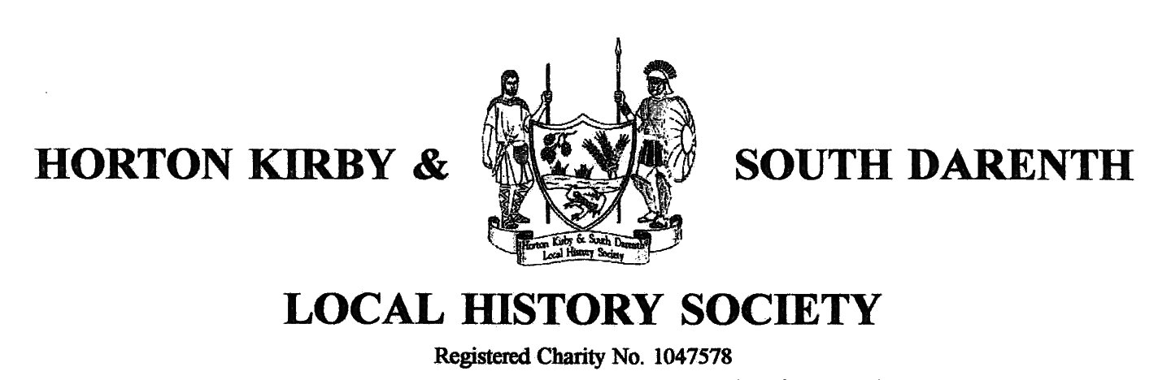

Minutes of the twentieth Annual General Meeting held on Monday 10th November 2014
held in the Village Hall, South Darenth.

1. Apologies for absence
Apologies were received from Richard Walsh, Barbara Cannell and from Pauline and Chas Evans. There were 33 members in attendance.

2. Minutes of AGM held on 11th November 2013
These were approved by the meeting and signed by the Chair as an accurate record.

3. Matters arising in Minutes
There were no matters arising.

4. To approve Treasurer’s Report and Accounts
The Treasurer presented the Report and Accounts for the year ended 31st August 2014, together with the Independent Auditor’s report. The meeting approved the adoption of the accounts. The Chairman thanked the Treasurer and the Independent Auditor, Philip McGarvey.

5. Future subscriptions
In the light of the increases over the years in the hire of the village hall and the cost of speakers it was agreed that membership fees should be raised to £7 for individuals and £10 for couples. The increase would not come into effect until September 2015.

6. To elect officers and members of the committee
The following were re-elected en-bloc for the coming year:
Chairman Terry Moyle
Vice-Chairman Malcolm Scott
Treasurer: Jan Ovenden
Committee: Barabara Cannell, Sarah Lewis, Peter Flewin and John Woodhead

7. To approve appointment of Independent Auditor
TM told the meeting that Mr Dunk had retired as Independent Auditor but that Philip McGarvey had been approached and was happy to take over the role.

8. Any Other Business
TM thanked members of the committee for their work this year and also the membership for their continued support and attendance. Jan, Paddy and Doreen were also given special thanks for preparing the refreshments at the meetings throughout the year and at the AGM.

There being no other business the meeting closed at 8:13pm.

